Student Name: Kapish Gupta UID: 24BAI70577
Branch: AIT-CSE (AIML) Section/Group: 24AIT_KRG-G2
Semester: 4
Subject Name: Database Management System Subject Code: 24CSH-298

EXPERIMENT 7
Design of a Parameterized PL/SQL Stored Procedure for Employee Count by Gender (CData, Toddle)
AIM
To design and implement a stored procedure that accepts gender as an input parameter and returns the total number of employees based on the given gender, demonstrating procedural programming and parameterized logic in PL/SQL.

OBJECTIVE
• To write and execute a stored procedure in PL/SQL
• To dynamically accept gender as an input parameter
• To compute and return employee count based on the given gender
SOFTWARE REQUIREMENTS
Database Management System:
Oracle Database Express Edition (Oracle XE)
PostgreSQL Database
Database Administration Tool / Client Tool:
Oracle SQL Developer (for Oracle XE)
pgAdmin (for PostgreSQL)

PROBLEM STATEMENT
Organizations require flexible reporting systems to analyze workforce distribution based on gender for:
- Compliance requirements
- Internal analytics
- Decision-making

PRACTICAL / EXPERIMENT STEPS
• Create an employee table (if not already present)
• Insert sample employee data with gender field
• Design a stored procedure that:
- Accepts gender as an input parameter
- Counts employees matching that gender
- Returns the result using an output parameter
• Execute the procedure with different gender inputs
• Display the output
STEP-WISE OUTPUT
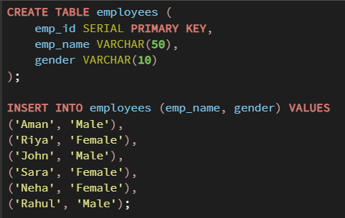

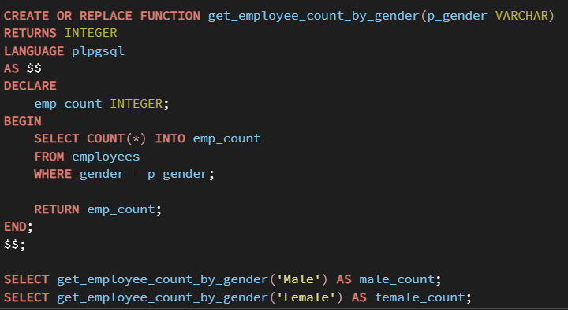

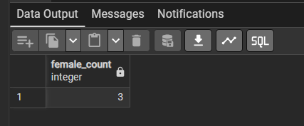

RESULT ANALYSIS
- Simple View
  - Created from a single table.
  - Executes quickly for small datasets.
  - No performance optimization for complex operations.
- Complex View
  - Includes joins and aggregation.
  - Slower than simple view because data is computed every time the query runs.
- Materialized View
  - Stores precomputed results physically.
  - Significantly faster for repeated queries.
  - Requires refresh mechanism to maintain updated data.

REAL-WORLD APPLICATION
Companies such as SanDisk, JTG, and PayPal handle large-scale transactional data.
In such organizations:
- Complex reports run frequently.
- Data warehouses require fast query responses.
- Business intelligence dashboards need optimized performance.
Materialized views are used to:
- Improve reporting speed.
- Reduce server workload.
- Enhance query optimization.
- Improve overall system performance.

LEARNING OUTCOME
After completing this experiment, the learner is able to:
After completing this experiment, the learner will be able to:
- Understand the structure of a stored procedure
- Use IN and OUT parameters effectively
- Pass dynamic inputs to procedures
- Apply aggregate functions (COUNT) in PL/SQL
- Develop reusable database logic for real-world applications (e.g., CData, Toddle)

CONCLUSION
This experiment demonstrates how PL/SQL stored procedures can be used to create dynamic and reusable database logic. By passing parameters and using aggregate functions, organizations can efficiently generate reports and insights based on specific conditions like gender.

